VEGETATIVE PROPAGATION OF Platanus orientalis L. (ORIENTAL PLANE TREE - CINAR)

Murat Zencirkiran^{1*} and Kamil Erken²

¹ Department of Landscape Architecture, Faculty of Agriculture, Uludag University,16059, Görükle Campus, Bursa,Turkey. *E-mail: mzencirkiran@uludag.edu.tr
² Atatürk Garden Cultures Central Research Institute, Yalova, Turkey.

Abstract

This study was carried out to determine the effects of different times of collection of cuttings and different auxins (IBA-NAA) and concentrations about the propagation of Platanus orientalis L. by cutting. Rooting (%), the number of roots per cutting and primary root length were seen, the best results obtained in November, December and October, respectively. In addition, relatively lower values were determined during spring (March and April) and summer (June and July) periods. On the other hand, it was found out that auxin applications were not effective on rooting of cuttings.
Key words: Platanus orientalis L., auxin, cutting collection time, propagation.

INTRODUCTION

Platanus orientalis L. is a tree species belonging to the Platanaceae. Fossil records indicate that Platanaceae have been an element of the northen hemisphere since the mid-Creraceous period. Most of the species diversity and taxonomic complexity resides in North America (where P.occidentalis L. is present) and northern Latin America. Differently, natural standings of P.orientalis L. are present in the Mediterranean region of south-Europe and south-western Asia (especially Turkey and Iran). It is likely that P.orientalis originated in geological times from divergences involving the intercontinental disjunction and other barriers (Sert et al. 2008, Pilotti et al. 2009).
P.orientalis L. can be found naturally in almost all forestlands, inside the streams, river bottoms in Turkey. They are monumental, long-lived trees that can grow taller up to 25-35 meters with a trunk diameter of more than 5 m and live for 2000 years. Trunks and branches are light grey or greenish-grey. The trunk is covered by a whitish-grey bark. The barks in the older trunks flake off in the form of small plates and gradually fall off. The light green colored leaves deeply have 5-7 lobed, broadly cuneate or truncate at base, lobes longer than broad, coarsely toothed or entire, glabrous or subglabrous at maturity. Petiole is quite long and length ranges between 3 and 8 cm. Fruits are sphere-shaped, compound, and 2 to 6 of them are found on a long leafstalk. The situation of compound fruit is descriptive characteristics of P.orientalis L. Compound fruit in P.occidentalis L., which is quite similar to P.orientalis L., are found individually or a few of them take place on a single axis (Davis 1982, Pamay 1992, Mataracı 2002, Anşin and Özkan 2006).
It is widely used in landscape design in our country (urban open green spaces – parks- arboretum etc., water fronts, industrial areas, shade bearer, street tree) and has numerous examples protected as natural monumental trees.
Platanus species can be propagated by means of generative and vegetative methods. The reactions against the propagation methods used vary from species to species (Dirr and Heuser 1987, Hartman et al. 2002). Propagation through seeds is a commonly used method. However, when propagated through seeds, there exists a possibility some of the small and delicate seeds not to germinate, because of the negative influence of external natural factors. Other factors that hamper the seed propagation of sp. Platanus are: treatment of the seeds before sowing and special care for the young and fragile germs. Along with this, rate of germination in seeds differs among the species and this rate ranges between 30-40 % in P.orientalis (Vlachov 1988, Anonymous 2003).
The studies carried out about the propagation of Platanus species by cutting were particularly intensive on the species of Platanus acerifolia Willd. and it was stated that the factors such as genotype, type of cutting (basal, median), the position of the cutting-donor shoot on the mother plant, cutting stem diameter humidity and temperature of the rooting medium, and time of collection of the cuttings were effective on rooting (Grolli et al. 2005). It was found that there is limited information about the propagation of Platanus orientalis L. by cutting (Dirr and Heuser 1987, Vlachov 1988, Khosrojerdi et al. 2006).
Application of auxin, particularly indole – 3 – butyric acid (IBA), is one of the most common and effective means to enhance rooting of cutting (Blazich 1988, Ritchie 1991, Hartmann et al. 2002, Leakey 2004).
On the other hand, auxin treatments have been produced contradictory results of Platanus species. In some cases, auxin were effective at increasing rooting; while in others, auxin-treated cuttings rooted as well as the untreated controls (Myers and Still 1979, Dirr and Heuser 1987, Vlochov 1988, Abdullah et al. 1989, Macdonald 1990, Panetsos et al. 1994, Gjuleva and Atanasov 1994, Schmidt 1998, Nicoloso et al. 1999, Dias et al. 1999, Santini 2001, Hartman et al. 2002, Grolli et al. 2005, Khosrojerdi et al. 2006,).
This study was conducted to determine the effects of different times of collection of cuttings and different auxins (IBA-NAA) and doses about the propagation of Platanus orientalis L. by cutting.
MATERIAL AND METHODS

The study was carried out at Atatürk Garden Cultures Central Research Institute-Yalova greenhouses between 2010 and 2011. The cuttings of Platanus orientalis L., forming the study material, were taken from sprouts which were 20-30 cm long, with 3-4 nods and 0.5-1 cm thick from the rootstock plants that were determined before.
In order to determine whether times of collecting cuttings were effective on rooting, the cuttings were prepared in January, February, March, April, May, June, July, October, November and December. No cuttings were prepared in August and September in the greenhouse where the experiences were carried out since internal temperature control was very difficult.
The cuttings prepared were kept in fungicide containing 2 gl-1 Benomyl for a 1 minute (Grolli et al. 2005), and then dried for 5 minutes. After this process, the cuttings were randomly divided into groups and applied Indole-3-Butyric acid (IBA) and Naphthalene Acetic acid (NAA) for 5 seconds. Doses of 1000, 2000, 3000 and 4000 ppm were used during the applications. Control group cuttings which were not exposed to application were kept in distilled water within the same time period.
Cuttings were planted in mist propagation which were found in glasshouse, contained perlite as rooting medium and whose under floor heating was arranged to 21-22ºC (Fig. 1). Misting was provided for 10 s every 15 min during the day (06⁰⁰-18⁰⁰ h) and for 10 s every 20 min at night (18⁰⁰-06⁰⁰ h) (Hunt et al. 2011).
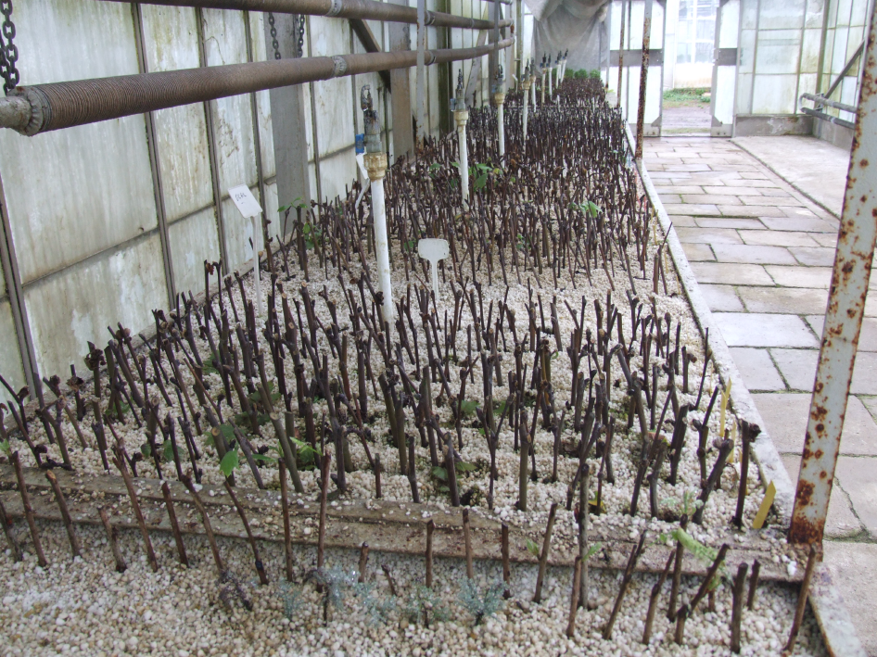
Fig. 1. Cuttings planted in mist propagation

The experiment was established using randomized plots in a factorial experimental design with three replicates comprised of 25 cutting each.
Analyses of variance, least significant difference (LSD) tests among means were performed on the measured data using the MINITAB (Minitab, Inc. USA, Minitab Release, 12.1). Statistically significant means were separated by the LSD test at the 0.05 level.
Data on percent rooting were transformed by the arcsine square root transformation before performing the statistical analysis.
RESULTS AND DISCUSSION

Rooting (%)

Different times of collection of cuttings were effective on the rate of rooting, the highest rooting was seen in November (36.40%) and December (23.47%), it was followed by the cuttings prepared in October (22.53%). The cuttings prepared in April did not root. (Table 1).
Table 1. Rooting percentage of Platanus orientalis L. cuttings of collected at different times in year.

Cutting collection time | Rooting (%)
January | 8.27 c*
February | 2.27 d
March | 2.13 d
April | 0.0 d
May | 10.67 c
June | 1.87 d
July | 3.46 d
October | 22.53 b
November | 36.40 a
December | 23.47 b
* Values in the column followed by different letters are significantly different (P≤0.05).

Although the IBA-applied cuttings cause more rooting than NAA-applied cuttings, this situation was found unimportant statistically (Table 2). At the same time, hormone doses also did not have a positive effect on rooting, the highest rooting rate was obtained in the control group cuttings (14.67 %) (Fig. 2).
Table 2. Rooting percentage of Platanus orientalis L. cuttings treated different auxin types.
Auxin type | Rooting (%)
IBA | 11.33 a*
NAA | 10.88 a
* Values in the column followed by different letters are significantly different (P≤0.05).

Fig. 2. Rooting percentage of Platanus orientalis L. cuttings treated different hormone concentrations (* Values in the column followed by different letters are significantly different (P≤0.05).
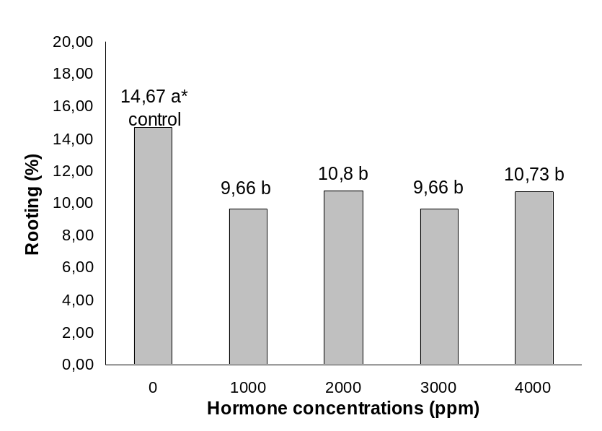

Root Number and Primary Root Length

It was determined that different times of collection of cuttings were effective on the mean root number and primary root length. The mean root number was found to be highest in the cuttings prepared in October; it was followed by those prepared in November. The primary root length was found to be the longest in the cuttings prepared in December and November (Table 3).

Table 3. Avarege root number and primary root length of P.orientalis L. cuttings of collected of different times of year.

Cutting collection time | Average root number | Primary root length (mm)
January | 2.25 c* | 28.59 bc*
February | 0.53 e | 2.09 d
March | 1.65 cd | 5.99 d
April | 0.0 e | 0.0 d
May | 3.71 b | 33.99 b
June | 0.90 de | 5.77 d
July | 1.64 cd | 22.98 c
October | 5.92 a | 33.45 b
November | 4.04 b | 51.70 a
December | 3.93 b | 58.69 a
*Values in the column followed by different letters are significantly different (P≤0.05).

On the other hand auxin types and doses were not found to be effective on the mean root number and primary root length (Fig 3 and 4, Table 4).
Fig. 3. Average root number of P.orientalis L. cuttings of treated different auxin types.

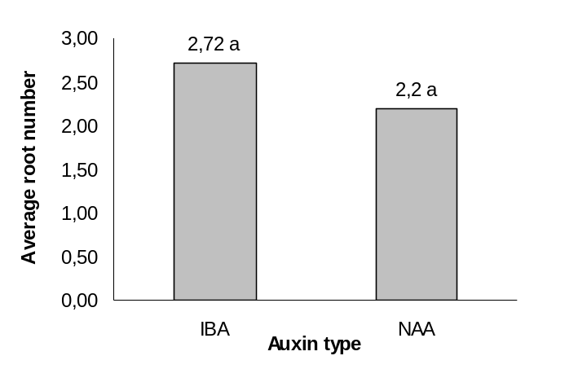
Fig. 4. Primary root length of P.orientalis L. cuttings of treated different auxin types.

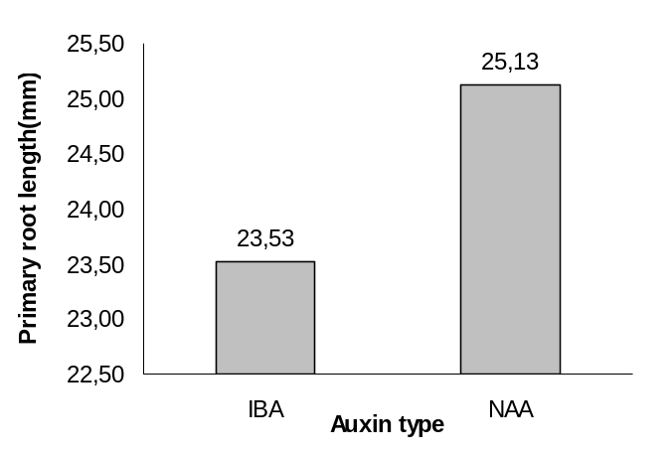
Table 4. Average root number and primary root length of P.orientalis L. cuttings of treated different hormone concentrations.
Hormone concentrations (ppm) | Average root number | Primary root length (mm)
Control | 2.53 | 24.03
1000 | 2.54 | 23.80
2000 | 2.64 | 26.15
3000 | 2.16 | 24.43
4000 | 2.41 | 23.20

As a result of this study carried out to determine the rooting performances of the cuttings of Platanus orientalis L.; the effects of different times of collection of cuttings were clearly seen. Rooting (%), the number of roots per cutting and primary root length were seen, the best results obtained in November, December and October, respectively. In addition, relatively lower values were determined during spring (March and April) and summer (June and July) periods. This situation conformed to the studies of Abou dahdah et al. 1975, Vlachov 1988, Grolli et al. 2005. These researches stated that cutting rooting was effected positively during the similar periods.
It was found out that auxin applications were not effective on rooting. No difference was found between auxin types and the doses used, more rooting was obtained in the control group cuttings that used no auxin.
In the previous studies about Platanus species it was emphasized that auxin applications brought about conflicting results and auxins sometimes were effective and sometimes remained (Dirr and Heuser 1987, Dias et al. 1999, Santini 2001, Grolli et al. 2005)
In conclusion;

1. It was determined that rooting rate of cuttings in Platanus orientalis L. was not very high, rooting rate changed depending on the time of getting cuttings and that the best rooting (36.40%) could be obtained from cuttings prepared in November.
2. It was seen that Auxin types and the doses used did not have an important effect on rooting and that they affected rooting negatively. In order to be able say whether auxin applications have any toxic effects on rooting, it was seen important that it should be tried in higher concentrations than those applied in the study.

REFERENCES

Abdullah Y.S., Al-Ashoo J., Abdullah M.O. (1989). Effect of soaking storage and scarification of cuttings on same growth characteristic of sycamore. Mesopotamia Journal of Agriculture, 21: 141-145.
Abou dahdah A.M., Shafiq L., Al Kimany A., Yahya M.D. (1975). Effects of seasonal variations in root formation and growth of cuttings of different trees and shrubs. Mesopotamia Journal of Agriculture, 10: 3-12.
Anonymous (2003). Seed propagation of Mediterranean trees and shrubs. APAT. Printed in Italy by I.G.E.R. srl- Roma,108 pp.
Anşin R., Özkan Z. C. (2006). Tohumlu Bitkiler (Spermatophytha). Odunsu Taksonlar.Karadeniz Teknik Üniversitesi, Orman Fakültesi, Genel Yayın No. 167, Fakülte Yayın No: 19. KTÜ Basımevi, Trabzon, 450 pp.
Blazich F. A. (1988). Chemical and formulations used to promote adventitious rooting. In: Davis, T.D., Haissig, B.E., Sankhla, N. (eds). Adventitious root formation in cuttings. Dioscorides Press, Portland, 132-149.
Davis P.H. (1982). Flora of Turkey and the East Aeagean Islands. Vol:VII. Edinburg at the University Press, 947 pp.
Dias R. M. S. L., Franco E. T. H., Dias C.A. (1999). Rooting of stem cuttings of different diameters of Platanus acerifolia (Aiton) Willdenow. Ciencia Florestal, 9(2): 127-136.
Dirr A.M., Heuser C. W.Jr. (1987). The Reference Manual of Woody Plant Propagation: From Seed to Tissue Culture. University Press, Athens, GA, USA, 238 p.
Gjuleva V., Atanasov A. (1994). Micropropagation of Platanus acerifolia in vitro. Silvae Genetica, 43: 215-218.
Grolli P.R., Morini S., Loreti F. (2005). Propagation of Platanus acerifolia Willd by Cutting. Journal of Horticultural Science and Biotechnology, 80 (6): 705-710.
Hartman H.T., Kester D.E., Davies F.T., Geneve R. L. (2002). Plant Propagation. Principles and Practices. Prentice Hall. NJ, USA, 727 pp.
Hunt M. A., Trueman S.I., Rasmussen A. (2011). Indole-3-butyric acid accelerates adventirious root formation and imoedes shoot growth of Pinus elliottii var. elliottii x P. caribaea var. hondurensis cuttings. New Forests, 41: 349-360.
Khosrojerdi I., Tabari M., Hosseini M., Rahmani A. (2006). Diameter and number of cutting bud impact on sprouting of Platanus orientalis. Journal of Agricultural Sciences and Natural Resources, 12(6): 189-194.
Leakey R. R. B. (2004). Physiology of vegetative reproduction. In: Burley, J., Evans, J., Youngquist, J.A. (eds). Encyclopedia of forest sciences. Academic Press. London, 1655-1668.
Mataracı T. (2002). Ağaçlar. Marmara Bölgesi Doğal Egzotik Ağaç ve Çalıları. TEMA Vakfı Yayını No: 39. 371 pp.
Mcdonald B. (1990). Practical Woody Plant Propagation for Nursery Growers. Vol.1. Timber Press, Protland, OR, USA, 669 pp.
Myers J.R., Stil S.M. (1979). Propagation London plane tree from cuttings. Plant Propagator, 25: 8-9.
Nicoloso F.T., Lazzari M., Fortunato R.P. (1999). Vegetative propagation of Platanus acerifolia Ait.(II): effect of zinc, boron and indolebutyric acid on rooting of cuttings. Ciencia Rural, 29 (3): 487-492.
Panetsos K. P., Scaltsoyiannes A. V., Alizoti P.G. (1994). Vegetative Propagation of Platanus orientalis x P. occidentalis F1 hybrids by Stem Cuttings. Forest Genetics, 1(3): 125-130.
Pamay B. (1992). Bitki Materyali I. Ağaç ve Ağaççıklar. Uycan, İstanbul, 64 pp.
Pilotti M., Brunetti A., Tizzani L., Marani O. (2009). Platanus x acerifolia genotypes surviving to inoculation with Ceratocystis platani (the agent of cancer stain): first screening and molecular characterization. Euphytica, 169: 1-17.
Ritchie G. A. (1991). The commercial use conifer rooted cuttings in forestry: a world overview. New Forests, 5: 247-275.
Santini A. (2001). II platano ibrido (Platanus x acerifolia L.) famiglia Platanaceae. Sherwood, 71: 37-41.
Schmidt D. (1998).Softwood propagation of Platanus x hispanica ‘Columbia’. Combined Proceeding of the International Plant Propagators’ Society, 48: 479-480.
Sert Ş., Kütahyalı C., İnan S., Talip Z., Çetinkaya B., Eral M. (2008). Biosoption of lanthanum and cerium from aqueous solutions by Platanus orientalis leaf powder. Hydrometallurgy, 90 (1): 13-18.
Vlachov D. D.(1988). Vegetative propagation of sp. Platanus L. through rooting of cuttings. Acta Horticulturae, 226: 375-378.

